Siena Heights University

At Kellogg Community College
Fall II Semester Course Syllabus 2017

Course Number & Title: PSY 360 COUNSELING TECHNIQUES AND PRACTICES

Dates: October 23rd – December 4th Meeting Time: Mondays 6 – 9:00 pm

Instructor: Dr. Shawn Talbot Phone: 269.965.3931 ext 2220

E-mail: talbots@kellogg.edu Credits: 3 credits

Siena Heights University Program Outcome Statement

Graduates of Siena Heights University programs will have gained the knowledge, skills, and attitudes necessary to continue developing as self-respecting professionals. They will be capable of:
- Making sense out of their daily work and personal lives:
- Taking appropriate actions:
- Realizing that their search for final answers must be life-long.
General Studies Learning Outcomes
“While a general education curriculum seeks to be both expansive and incisive, at Siena Heights University it may be characterized as challenging students in these areas:
  - Liberal Arts Learning
  - Modes of Learning
  - Communication Skills
  - Diversity in Community
  - Ethical and Moral Understanding
  - Social Responsibility
  - Life-long Learning”

Community Services Program Learning Outcomes
- Develop an interdisciplinary and ethical approach to the professional practice of community service.
- Develop skills to access, evaluate and utilize social research in community service work, and be able to link theory and practice.
- Develop effective communication and interpersonal skills appropriate for use in the roles of community service practice.
- Know and utilize methods appropriate for the process of planned change in communities and agencies.

Course Description
This course offers an introduction to listening skills, both in a group and in one-on-one settings. Body language, attending skills, empathy skills and sensory experiences are topics included in this course.
Course Objectives
- To understand the application of introductory counseling techniques and communication skills for various populations and situations.
- To develop empathic listening, active listening skills, problem identification and problem solving skills for use in community or organizational settings.
- To demonstrate the ability to apply appropriate communication skills in simulated situations in class.
- To demonstrate ability to research counseling topics and apply theories and practice from that research.
- To identify community referral resources and appropriate procedures for referrals.
- To encourage self-knowledge and growth in interpersonal skills.
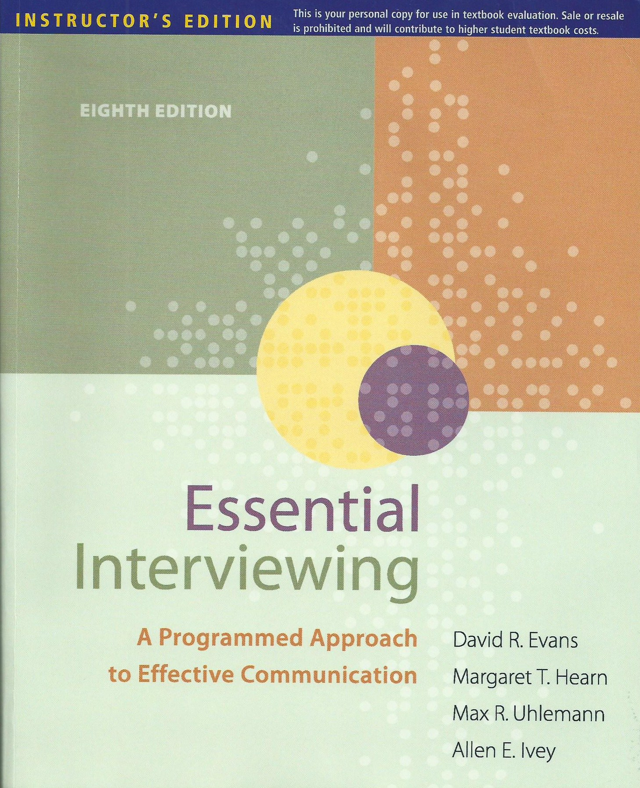

Text(s) and Materials Required
Evans, D., Hearn, M. T., Uhlemann, M. R., & Ivey, A. E. (2011). Essential interviewing: A programmed approach to effective communication (8th ed.). Brooks/Cole/Cengage; Belmont, CA. ISBN: 978-0-8400-3471-7
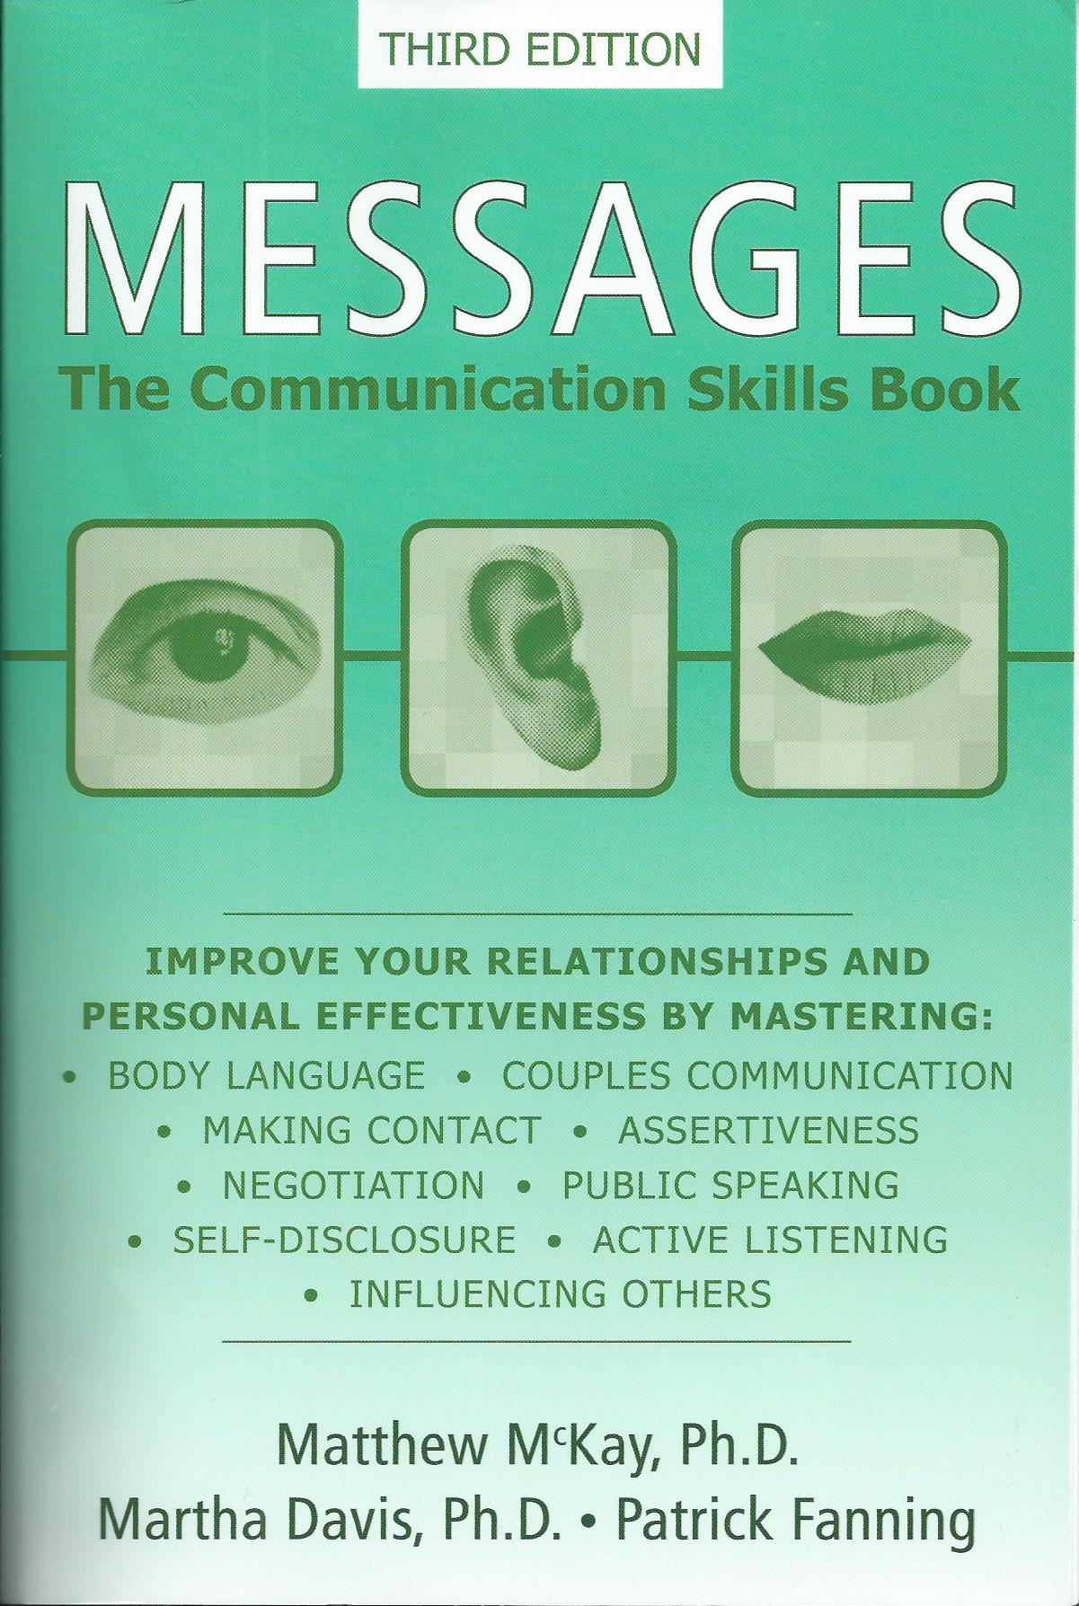
McKay, M., Davis, M., & Fanning P. (2009). Messages. New Harbinger Publications; Oakland, CA. ISBN: 978-1-57224-592-1
LATE ASSIGNMENT POLICY - If a student needs to turn in work late he/she must contact the instructor prior to the due date to make the arrangements. Late assignments will be accepted only until the next class period. (which means the final paper will not be accepted late). Students will receive a 10% decrease in points begining the day after the assignment is due for late assignments.
On a side note, a broken computer is not a valid excuse for turning in work late. If you do not already have a flash drive, I recommend you get one (a small one is all you need for backing up documents and they are very reasonably priced) and save all your work on it. Losing work in this way is an easily preventable disaster.
Pre-Course Assignment: Read chapter one of the Evans text to prepare for class. Also review the syllabus and prepare any questions you might have in regards to its content or the class in general.
Time Estimate: This is an accelerated class. Students are expected to commit about 120 hours of work to complete a 3-credit course; so plan for approximately 9-15 hours per week to read, write and review drafts, complete essays, prepare for and participate in the threaded discussions, and perform research. I recognize that you have jobs, families and other responsibilities, but a college education doesn't really have any short cuts.
Attendance, Effort, and Participation: The student will be expected to attend all classes, to arrive and leave on time. Attendance will be taken; absences, late arrivals and leaving early will affect the student's grade. Absences are unexcused, except in the case of a death in the family, personal injury, or any unavoidable emergency that renders the student unable to attend classes. Students who miss more than one session will have their grade reduced one full grade. Students are advised to communicate with the instructor, preferably by phone, before an expected absence, if possible. Furthermore, students who participate in class discussions and activities and who make an effort to turn in thoughtful, well-crafted work will have a better chance for a good grade than those students who do not follow such a course of action.
Students with Disabilities - Siena Heights University is committed to providing a learning environment that benefits all students. Pursuant to the Americans with Disabilities Act of 1990, a reasonable accommodations policy for students with disabilities requires a student to provide written documentation of his/her disability to the Academic Advising Office. If a student is in need of an accommodation based on the impact of a disability, please contact me so we can discuss the course format, anticipate your needs and explore potential accommodations. I rely on the Office for Students with Disabilities for assistance in verifying the need for accommodations and developing accommodation strategies. If you have not previously registered with the Office for Students with Disabilities, I encourage you to do so.
*Academic dishonesty is unethical behavior, which violates the standards of scholarly conduct. It includes such behaviors as cheating on assignments or examinations, plagiarizing, submitting the same or essentially the same papers for more than one course without the consent of all instructors concerned, misappropriating library materials, or the destroying or tampering with computer files. Also included in academic dishonesty is knowingly or intentionally helping another to violate any part of this policy. The result of such behaviors will be dismissal and failure of the course.
*Plagiarism is the failure to give credit for the use of material from outside sources, including the Internet. It includes, but is not limited to: verbatim use of a quote without quotation marks and adequate documentation; submission of a paper, prepared in whole or part by another person, as one’s own work; using the ideas, facts, words, photographs, pictures, graphics, or data of someone and claiming them as your own; or not documenting facts, words or data gathered during research.

COUNSELING
TECHNIQUES & PRACTICES PSY360
Class Schedule & Homework assignments:

Week # 1 – October 23: ALL CLASS MEETING
Before coming to class read chapter 1 in the Evans textbook and review the table of contents of the Messages text. Introductions and course guidelines/schedule will be covered tonight.

Week # 2 – October 30: Questioning and Attending Behaviors
Read chapters 2 &3 in the Evans text, chapter 1 in the Messages text.
Submit via e-mail an applied observation paper for the skills discussed in this week’s materials and readings.
A guidance paper and grading rubric will be provided for the Resource-ography.

Week # 3 – November 6: Reflection and Validation
Read chapters 4 and 5 in the Evans text, chapter 11 in the Messages text. We will discuss and practice the intake process and form.
Submit via e-mail an applied observation paper for the skills discussed in this week’s materials and readings.
Homework: Practice these techniques throughout the next two weeks. Practice these skills on family, friends, co-workers etc. & record your progress/impressions. We will be discussing your observations and experiences in class.

Week # 4 – November 13: Confrontation and Assertiveness ALL CLASS MEETING
Read chapters 6 & 7 of the Evans text and chapter 9 in the Messages text.
Submit via e-mail an applied observation paper for the skills discussed in this week’s materials and readings.
A guidance paper and grading rubric will be provided for the Intake Assessment.
Intake Assessment Practice and time for its completion in class.
Resource-ography Due

Week # 5 – November 20: Disclosure and Expression of Emotion
Read chapters 8 & 9 in the Evans text and chapter 2 in the messages text. We will also be talking about each student’s impressions and experiences in completing the intake process.
Submit via e-mail an applied observation paper for the skills discussed in this week’s materials and readings.

Week # 6 – November 27: Information giving and Interpreting/Judgments
Read chapters 10 & 11 in the Evans text and chapter 13 of the messages text.
Tonight’s focus is on challenging the blind spots of both the client and counselor. Submit via e-mail an applied observation paper for the skills discussed in this week’s materials and readings.

Week # 7 – December 4: Enlisting Cooperation and Performing Negotiation
Read chapters 12 and 13 in the Evans text and chapter 12 in the Messages text.
Submit via e-mail an applied observation paper for the skills discussed in this week’s materials and readings.

Week # 8 –December 11: ALL CLASS MEETING
Read chapter 14 in the Evans text. We will do a final review and practice of our skills of listening, and the final papers will be collected.
Final Option Papers are Due

ASSIGNMENTS
QUALITY OF WORK:
All papers are to be typed, double-spaced, in Times New Roman, 12-point font, 1 inch margins. All papers are to be written in APA style. All research is to be reported in APA style.

OPTION PAPER (100 pts):
Identify at least 5 different communication theories, concepts or skills which are discussed in either the class or the class resources and explaining how these are used or observed in a personal or professional setting. Also include your belief as to if their use is beneficial or detrimental and why.
Or
Research & interview of a helping professional in Community Service Work - Someone who is working in an area in which you might like to work. This should be at least a 3 - 4 Page Typewritten Report which includes both your questions, their responses and your overall opinion of the interview. Consider developing questions consistent with the course subject matter (i.e. What types of listening skills do you use most often? Are there any skills that you find yourself using more than others?) Approximately 10 – 15 questions (at least half open-ended) is considered appropriate.

Intake Assessment (100 pts):
Students will utilize both listening skills and their ability to interview or gain information in order to complete a typical intake form/initial assessment. The process for the appropriate use of this form will be discussed, reviewed and practiced in class. (4)

A Resource-ography (50 pts):
The student will research and report on the community services available for people in your community. What is out there for homeless, help with turning utilities on if they are shut off, counseling for children etc. I am expecting a listing of everything that you can find, you will not be given full credit for a job done part way. I expect at least 3 - 4 pages in a booklet format with a critique of each identified resource. Explain how they communicate their service and what they did well or in what they could have improved (concerning their mode and method of communication).

GRADING POLICY:
This class is designed to teach communication skills and to practice these skills during class time. CLASS ATTENDANCE AND PARTICIPATION IS VITAL.

• Class attendance and participation (3 classes at 10 points each, 6 application papers at 20 pts each) 150 pts total
• Option Paper 100 pts total
• Intake Paper 100 pts total
• Resource-ography 50 pts total
TOTAL 400 points
100 – 97 % 400 – 388 = A+
96 – 94 % 387 – 376 = A
93 – 90 % 375 – 360 = A -
89 – 87 % 359 – 348 = B +
86 – 84 % 347 - 336 = B
83 – 80 % 336 – 320 = B -
79 - 70% 319 – 280 = C
69 – 60 % 279 – 240 = D

