Section 10.5

Piecewise Continuous and Periodic Functions



Ex. 

Ex. 

Ex. 



Periodic function   
Theorem Transforms of period functions

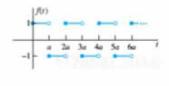Example 